***GreenCrowd***

**Version *1.0***

***02/22/2023***

Project Specification

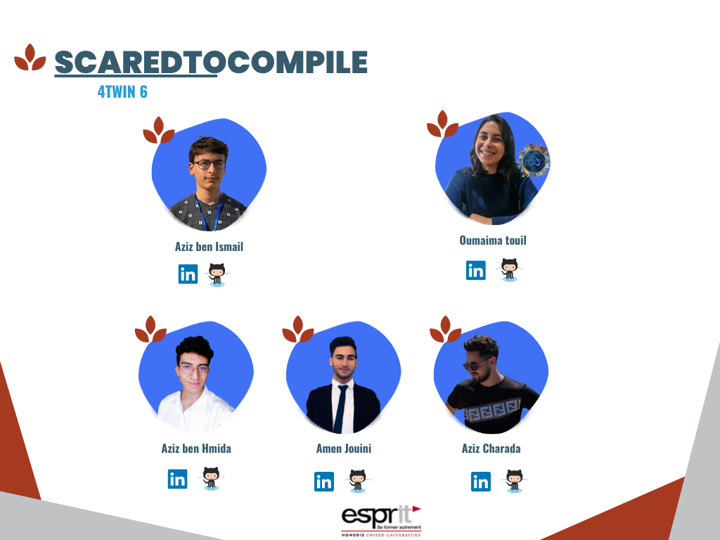

1. thanks 3

2. Introduction 4

3. Overall description 4

a. Project purpose 4

b. Project description 4

c. Project scope 5

i. Overview 5

ii. Features 5

iii. Deliverables 5

d. Assumptions / Constraints / Standards 5

i. Assumptions: 6

ii. Constraints: 6

iii. Standards: 6

4. state of the art 6

5. Business features specification (V) 7

6. Technical specification 9

a. Technical architecture : 9

b. Languages and frameworks 10

i. Express 10

ii. React 11

c. Software tools 11

i. Visual Studio Code 11

ii. Git & GitHub 12

d. Material tools 12

7. Other requirements 12

1. thanks

I would like to sincerely thank you for your invaluable help throughout the preparation of our web application report. Your unwavering support, insightful advice, and expertise have been of great assistance to us.

Your patience, availability, and ability to guide us with tact and kindness have been essential in enabling us to achieve our goals and produce quality work.

We are extremely grateful for all that you have done for us, and we want to express our heartfelt appreciation for your commitment and dedication. We have been fortunate to have such a competent and attentive tutor, and we hope to have the opportunity to work with you again in the future.

Once again, thank you very much for everything.

1. Introduction

Welcome to our platform, a unique crowdfunding platform designed to support ecological projects in Africa. Our platform is a revolutionary tool that enables environmentally-conscious entrepreneurs to take their validated projects to the next level by finding motivated employees in their field and accessing the resources of fab labs.

Our platform is dedicated to supporting the development of environmentally-friendly projects across Africa. Our goal is to provide a platform for entrepreneurs to showcase their innovative ideas, connect with potential investors and supporters, and ultimately receive the necessary funding to bring their projects to life.

With a system of badges, we aim to motivate our users and incentivize actions that align with our mission. By meeting specific criteria, users can earn badges and show their dedication to the cause of supporting sustainable projects in Africa.

Thank you for joining us on this journey to support ecological projects in Africa, and we hope you enjoy using our platform.

1. Overall description
   1. Project purpose

To create a crowdfunding Web Application that allows the unemployed and those with ideas to raise money for their projects to solve problems and advance the economy in Africa.

* 1. Project description

Our web application is a crowdfunding platform that allows users to discover and support innovative and creative projects in various fields. With our new evaluation module, users can earn badges by fulfilling certain criteria, such as supporting multiple projects, encouraging their friends to participate, and more.

Additionally, our application offers a unique option for projects that require specific technical support: collaboration with fab labs. Users can choose to support a project with the help of a fab lab, which offers specialized tools and skills to help project owners bring their idea to life.

By using our crowdfunding platform with the ability to earn badges and collaborate with fab labs, users can help promote innovation and support projects that have the potential to make a real difference in the world.

* 1. Project scope

1. **Overview**

The objective of this project is to develop a web-based crowdfunding platform that enables users to discover, support, and collaborate on innovative projects. The platform will include a module for badge validation to encourage user engagement and a feature for connecting projects with fab labs for specialized technical support

1. Features

User Registration and Login - users will be required to create an account in order to access the platform and support projects.

Project Discovery - users will be able to browse a curated list of projects that have been submitted to the platform, filtered by category, popularity, and other relevant criteria.

Project Submission - project owners will be able to submit their ideas to the platform for consideration.

Project Support - users will be able to contribute to projects they are interested in, with multiple funding options available.

Badge evaluation - a module will be included to provide users with badges for fulfilling certain criteria, such as supporting multiple projects, encouraging their friends to participate, and more.

Fab Lab Collaboration - a feature will be included to connect projects with fab labs for specialized technical support.

User Profile Management - users will be able to manage their profiles and view their activity history.

1. **Deliverables**

* Web application with all the features mentioned above.
* User and technical documentation for the platform.
* Testing and quality assurance reports.
* Maintenance and support documentation.
  1. Assumptions / Constraints / Standards

The Web Application will be developed using the latest web technologies and standards. The site must be secure, reliable, and easy to use. The site must also be compliant with all applicable privacy and security regulations.

1. Assumptions:

The development team will have access to necessary web development tools including frameworks and libraries, as well as any required third-party services.

All projects submitted to the platform will be reviewed by a team of moderators to ensure they meet quality and suitability standards.

Any technical support provided by fab labs will be subject to availability and capacity.

1. Constraints:

The project must be completed within a specified timeframe and budget.

The platform must comply with relevant legal and regulatory requirements.

The development team must ensure the security and confidentiality of user information and payment data.

The platform must be scalable and capable of handling an increasing volume of users and projects.

1. Standards:

The platform will comply with applicable laws and regulations related to crowdfunding and online payments.

The user interface will be designed to be user-friendly, accessible, and responsive across different devices and screen sizes.

The platform will be designed and developed following industry best practices for security and data protection.

The platform will be tested thoroughly to ensure its functionality, performance, and reliability.

1. state of the art

* Responsive design for optimal user experience on different devices.
* Secure online payment platform for Investment.
* Tools for tracking and managing crowdfunding campaigns.
* Integration with social networks for sharing campaigns.
* Customization options for campaign pages of project creators.
* Notification system for project updates.
* Analytics to assess the performance of campaigns and market trends.

1. Business features specification (V)

|  |  |  |  |
| --- | --- | --- | --- |
| **Module** | **Submodules** | **System features** | **Description** |
| project and investment management | project management | System feature 1.1.1 | Ability to create a project by entering a title, description, image and fundraising goal |
| System feature 1.1.2 | Ability to modify a project |
| System feature 1.1.3 | Ability to delete a project |
| System feature 1.1.4 | Possibility to consult my projects |
| investment management | System feature 1.2.1 | Ability to invest in a project |
| System feature 1.2.2 | Ability to modify an invest in a project |
| System feature 1.2.3 | Ability to consult my investments |
| System feature 1.2.4 | Ability to delete an invest in a project |
| User management  And chat | User management | System feature 1.1.1 | Ability to sign up and sign in |
| System feature 1.1.2 | Ability to modify user (profile) |
| System feature 1.1.3 | Ability to delete user |
| System feature 1.1.4 | Ability to view profile |
| chat | System feature 1.2.1 | Ability to send a message |
| System feature 1.2.2 | Ability to view messages |
| System feature 1.2.3 | Ability to delete message |
| System feature 1.2.4 | Ability to update message |
| Fablabs Management | Fablabs Management | System feature 1.1.1 | Ability to join the platform after an administrative approval. |
| System feature 1.1.2 | Ability to support a project idea. |
| System feature 1.1.3 | Ability to discuss with the person behind the idea. |
| System feature 1.2.1 | Ability to create an event |
| Event  Management | System feature 1.2.2 | Ability to update an event |
| System feature 1.2.3 | Ability to delete an event |
| System feature 1.2.4 | Ability to consult an event |
| Recruiting Management | Employees Management | System feature 1.1.1 | Ability to add an offer |
| System feature 1.1.2 | Ability to modify an offer |
| System feature 1.1.3 | Ability to delete an offer |
| System feature 1.1.4 | Ability to consult offers |
| Recruiting Management | System feature 1.2.1 | Ability to accept candidates |
| System feature 1.2.2 | Ability to refuse candidates |
| Evaluation management | Evaluation Management | System feature 1.1.1 | Ability to add XP |
| System feature 1.1.2 | Ability to add badges |
| System feature 1.1.3 | Ability to delete badges |
| System feature 1.1.4 | Ability to consult LVL USER |
| Rating management | System feature 1.2.1 | Ability to add rate |
| System feature 1.2.2 | Ability to modify an rate |
| System feature 1.2.3 | Ability to add XP |
| System feature 1.2.4 | Ability to add badges |

1. Technical specification
   1. Technical architecture :

Monolithic architecture: This architecture is the simplest and involves a single application that includes all features. This may be appropriate for small to medium-sized applications, but can become difficult to maintain and scale as the application grows.

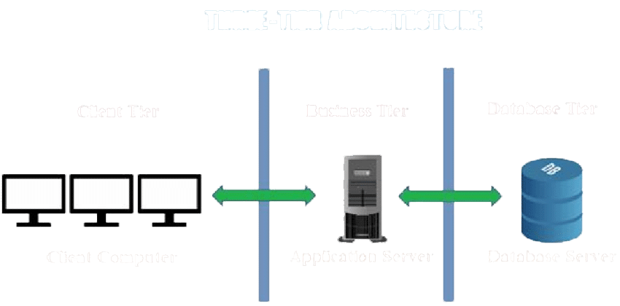

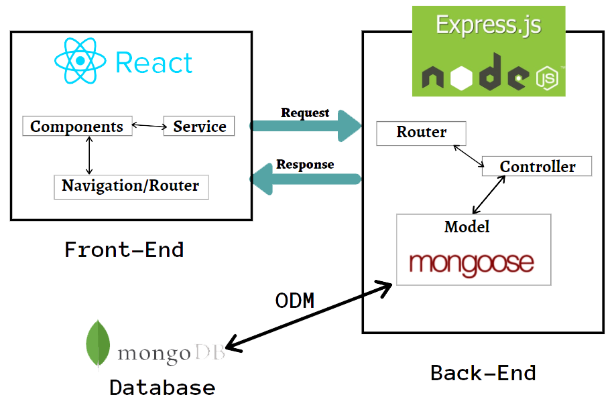

* 1. Languages and frameworks

1. Express

Besoin de plus de flexibilité et de contrôle sur les composants serveur Software tools

Ease of Getting Started**:** Express is a lightweight and easy-to-use library for building web applications, making it a popular choice for beginner developers.

Flexibility:Express is extremely flexible and can be used to build a wide variety of web applications, from simple sites to enterprise level applications.

Interoperability with other technologies:Express can be used in conjunction with other technologies, such as Node.js and MongoDB, to build more complete applications**.**

Rich ecosystem:Express is supported by a large community of developers and has a rich ecosystem of libraries and packages to extend the core functionality of the library.

Abundant documentation and resources:There are an abundance of online resources for learning and using Express, including blog posts, video tutorials, discussion forums, and more.

Speed of development**:** Express facilitates rapid application development by providing features such as HTTP request handling, route handling, and middleware handling, allowing developers to focus on their application's key functionality.

1. React

**besoin d'une solution simple et flexible pour construire des interfaces utilisateur**

Ease of Use: React is known for its simplicity and ease of use, making it a popular choice for both new and experienced developers.

High performance: React uses a reconciliation system to manage UI updates, which helps ensure fast and smooth performance for applications.

Component reusability: React encourages component reuse, allowing developers to build applications faster using prebuilt components.

Rich ecosystem: React is supported by a large community of developers and has a rich ecosystem of libraries and packages to extend the core functionality of the library.

Interoperability with other technologies: React can be used with other technologies, such as Node.js, to build more complete applications.

Abundant documents and resources: There are an abundance of online resources for learning and using React, including blog posts, video tutorials, discussion forums, and moresoftware tools

* 1. Software tools

1. Visual Studio Code

Friendly User Interface: Visual Studio Code has an intuitive and easy to use user interface that allows developers to work efficiently on their code.

Extensions and Plugins: Visual Studio Code has a large ecosystem of extensions and plugins that can be used to extend software functionality and add additional features for developers.

Built-in debugging features: Visual Studio Code includes built-in debugging features to help developers diagnose and resolve errors in their code.

1. Git & GitHub

Outils de développement: Des outils tels que Git, GitHub, Bitbucket ou SVN peuvent être utilisés pour gérer le code source et le suivi des modifications de votre site web.

* 1. Material tools

Personal computer: A personal computer is required to design, develop and manage a crowdfunding site.

Web design software: Software such as Adobe Dreamweaver, Wix or WordPress can be used to design the website.

Web server: To host and run the website, you will need a dedicated web server or a shared web host.

Domain name and storage space: You will need a domain name and storage space to store your website files.

1. Other requirements

|  |  |
| --- | --- |
| Attractive and functional design and ergonomics: | this refers to the visual design of the site and how user-friendly it is. It should be easy to understand and navigate for a positive user experience. |
| Responsive design for compatibility with different devices: | this criterion ensures that the site displays correctly on different types of devices, such as desktop computers, tablets,and smartphones. |
| Fast and reliable performance: | it is important that the site is fast and reliable, with no excessive loading times and no frequent errors. |
| Easy search and navigation functionality: | users should be able to easily find what they are looking for on the site through an efficient search function and clear navigation. |
| Social media sharing options: | the site should offer options for users to share content on social media platforms. |
| Compliance with security and privacy standards (e.g. SSL): | the site should adhere to appropriate security and privacy standards to protect user data. |
| Integrations with marketing and analytics tools for better performance understanding: | the site should have integrations with tools to help track and analyze performance. |
| Clear documentation and available technical support: | the site should have clear documentation and technical support available for users. |